

Architectural and engineering specifications

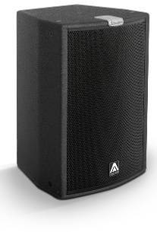
JK10

• The 2-way full range loudspeaker system shall have one direct radiating ferrite magnet 10-inch low frequency transducer and one 1,4-inch voice coil diameter, PETP diaphragm ferrite magnet compression driver loaded onto an assymmetrical rotational horn. Low frequency transducer shall be rated at a nominal impedance of 8 ohms. High frequency transducer shall be rated at a nominal impedance of 8 ohms.

• The usable bandwidth shall be 52Hz to 18kHz (-10dB).

• The system’s horizontal coverage shall be 50º to 100º, with vertical coverage of 55º.

• SPL, measured at 1W and 1m under free field conditions shall be 97dB.

• Maximum continuous musical program shall be 500W.

• Enclosure shall be bass-reflex type with two lateral round ducts.

• Enclosure cabinet construction shall consist of birch plywood with a black textured finish. Dimensions shall be 365 mm (14,4 inch) wide, 539 mm (21,2 inch) high, 340 mm (13,4 inch) deep. Enclosure weight shall be 16,3 Kg.

• The front enclosure shall be protected by a steel grille with acoustically transparent foam. The grille shall be secured via screws to keep it in place when facing the cabinet downwards.

• The enclosure shall include internal hardware for rigging and shall be used in conjunction with dedicated rigging accessories. Rigging accessories shall be affixed with special crop resistant screws.

• The cabinet shall feature a 35mm (1,38 inch) diameter pole mount socket mounted on the bottom side, for a standard tripod.

• Electrical connections shall be made via one of the two 4-pole NL4MPR Speakon connectors with the following configuration: +1/-1 signal input, +2/-2 disconnected.

• The system shall include an internal passive crossover.

• The loudspeaker system shall be the Master Audio® Joker JK10.
• The rigging accessories shall be the Master Audio® ACR-M8, SP-2610, SP-35, HR-1015.

